**Mandatory 5**

Pablo Martín García, Aaron Reboredo Vázquez

**Comments and explanation on the changes:**

According to the feedback received:

We have gone deeper into gameplay and mechanics in the description of the game, giving more details and explanations.

We have changed the gameplay showing the gameplay. Now the video is the recording of a part of a walkthrough of the game.

We have talked more about the mechanics reception in the public reception section.

We have expanded the “Juice”, “Windex” and “Oil” sections making them more specific and describing their possible improvements and our fixes better. We have also given examples of games that do the things better where needed (Windex section).

We have polished the “full design” section having in mind the discussion with other groups and we have written it including instructions and specific changes that could be presented to programmers, artist and designers.

**Mandatory Assignment 5: UI/UX and Gameplay**

Aaron Reboredo Vázquez & Pablo Martín García



1. **The Game**

***Assassin's Creed: Revelations*** is a [third-person](https://en.wikipedia.org/wiki/Third-person_perspective) [action-adventure](https://en.wikipedia.org/wiki/Action-adventure_game) [video gam](https://en.wikipedia.org/wiki/Video_game)e in which you take mainly the roll of an assassin, Ezio Auditore, whose mission is to stop the Templar desires of ruling the world.

Assassin's Creed: Revelations is set in an [open world](https://en.wikipedia.org/wiki/Open_world), in this case, the game occurs mostly in the city of Constantinople.

Assassin’s Creed: Revelations is the end of a saga, mainly starred in by Ezio Auditore, but also creating a link with the main character of the video game that started everything, Altair.

In this episode, we witness the final journey of Ezio Auditore, looking for answers of his ancestor, Altair. This adventure will lead Ezio to Constantinople in the seek of five keys to open Altair’s library in Masyaf in order to discover the secrets of the assassins.

Becoming Ezio Auditore allows you to use your assassin abilities like parkour. Running, climbing and jumping long distances allows the player to explore the entire city looking for resources and moving all around the city to reach new heights, mission points and going unnoticed to the enemies.

Parkour also allows the player to reach new strategic positions to kill enemies silently from above or let him have a better view of the battlefield to develop new or possible tactics to kill all the targets.

Your combat abilities, as the use of a multiple number of different weapons or your stealth aptitudesallows the player to customize his combat style to eliminate different types of targets and enemies in different ways. The player can choose between the face-to-face combat or killing all the enemies in the surroundings without raising suspicions.

In terms of gameplay and the mechanics there are no a big difference with the previous games of the saga. the Assassins Creed saga. Climbing buildings and free running allow us to move all around the city and take advantage of the heights to avoid guards on the ground, have more visibility of the mission areas. This situation also allows us planning combat strategies or use the position to kill enemies from above. In addition in Assassin's creed revelations we have the hook blade (an improvement of the hidden blades, the iconic weapon of the Assassins Creed saga), a gadget that allow us to climb even faster, reach higher heights and use the new ziplines that we will find all around the city. A new way to cover longer distances between roofs and buildings faster and more efficiently.

In terms of combat everything is almost the same. We can perform silent kills using our hidden blades that will end with the life of our enemy instantly or face the enemy in a face to face combat. In this case we will have the option to attack the enemies using different weapons for the melee combat as the hidden blades, swords or knives or even our fists. In Assassin's creed revelations killing enemies with the hidden blades will result in a different movement set using the hook blade and that will show us new killing animations never seen before on the saga.

We can perform distance attacks using weapons as throwing knives, crossbows or bombs that will allow us to kill, stun or confuse, in the case of the smoke bombs, enemies.

The rest of the gameplay features are quite similar. Complete missions to advance on the story, reach the peaks of watchtower to unlock the view of new areas on the map, improve your equipment to become a more competent adversary, buy shops to increase your incomes to spend in new and better improvements ...

**2. Company and public reception**

We have taken this video to show the gameplay of the game:

# Assassin's Creed: Revelations - Walkthrough - Part 1 (PC) [HD]

<https://youtu.be/dBRIJqHKknE?t=620>

Assassin's Creed Revelations was developed by [Ubisoft Montreal](https://en.wikipedia.org/wiki/Ubisoft_Montreal) and published by [Ubisoft](https://en.wikipedia.org/wiki/Ubisoft).

Ubisoft is a French [video game company](https://en.wikipedia.org/wiki/Video_game_company) that have some development studios across the world. It is responsible of a high number of AAA titles and well known franchises as [Assassin's Creed](https://en.wikipedia.org/wiki/Assassin%27s_Creed), [Far Cry](https://en.wikipedia.org/wiki/Far_Cry_(series)), [Just Dance](https://en.wikipedia.org/wiki/Just_Dance_(video_game_series)), [Prince of Persia](https://en.wikipedia.org/wiki/Prince_of_Persia), [Rayman](https://en.wikipedia.org/wiki/Rayman), [Raving Rabbids](https://en.wikipedia.org/wiki/Raving_Rabbids), and [Tom Clancy's](https://en.wikipedia.org/wiki/Tom_Clancy%27s) games.

Ubisoft Montreal is a Canadian [video game developer](https://en.wikipedia.org/wiki/Video_game_developer) and a subsidiary of [Ubisoft](https://en.wikipedia.org/wiki/Ubisoft) based in [Montreal](https://en.wikipedia.org/wiki/Montreal), [Quebec](https://en.wikipedia.org/wiki/Quebec). They have been making video games since 1995, from small projects like children games to another successful games and sagas as Splinter Cell, Far Cry, Watch Dogs, For Honor and other games of the Assassins Creed saga.

The game was pretty good accepted by the critics and players. It was the final journey of Ezio Auditore, the most popular assassin in those days and even in the present ones. The game promised to give an end to his story and Altair’s, using Desmond as the link between them.

The gameplay didn’t evolve so much, only a couple of new mechanics like the hook and customizable bombs were introduced.

However, the video game series had not been overplayed so much as nowadays so these new mechanics were well received by the users.

Most of the players agreed that the hook speeded up the movement across the city and added new possibilities to face the different missions.

Equally, the different bombs the game allowed to create offered new ways to distract and kill enemies.

These two new mechanics and their interaction with the old ones rewarded the assassin’s creed formula turning fresh and interesting again for the players.

After the story fall that Assassin’s Creed Brotherhood was, this videogame recovered the narrative quality demanded by the players giving another turn around to its gameplay mechanics, offering the final touch to an epic character and his saga.

Nowadays, the game has grades of 80/100 and higher, that don’t decrease, turning the Ezio Saga into one of the greatest and memorable stories of the video games.

**3. Mechanics that can be improved**

**Improved Feedback (“Juice”):** one of the things related to the feedback that we think it can be improved is the speed feeling when you perform a faith jump and when you use the city zip lines or the parachute. We suggest adding some fixes to simulate that speed feeling as the Marvel’s Spider-Man videogame does when the player plummets.

**Assassin's Creed Revelations** captures and link to videos that show our elections for the Improved feedback:

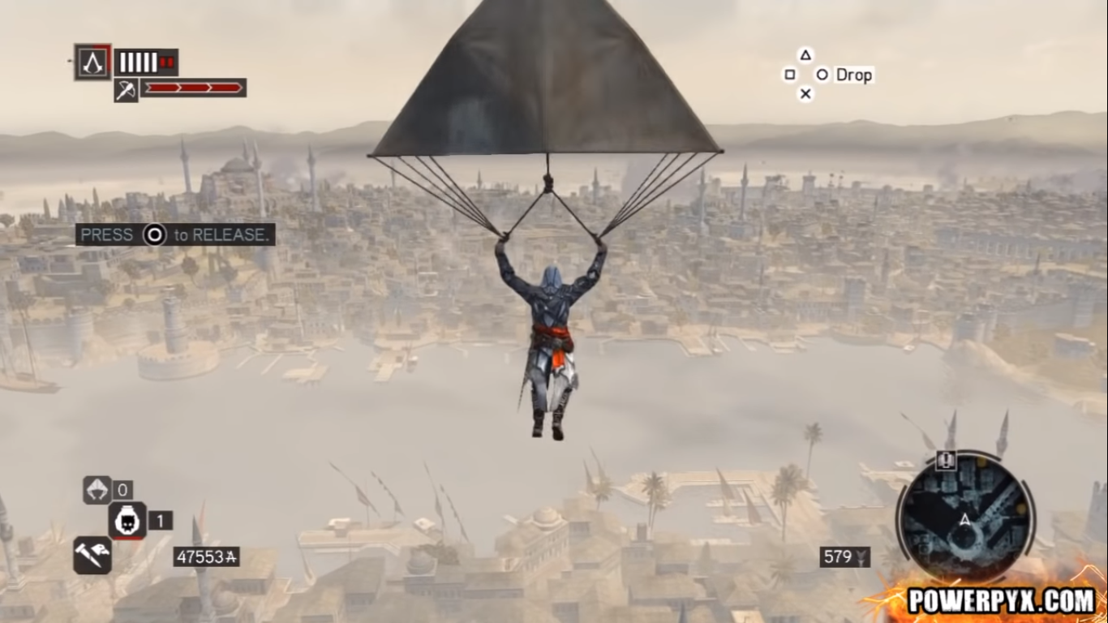

<https://youtu.be/Qes3jN_BjDw?t=17>

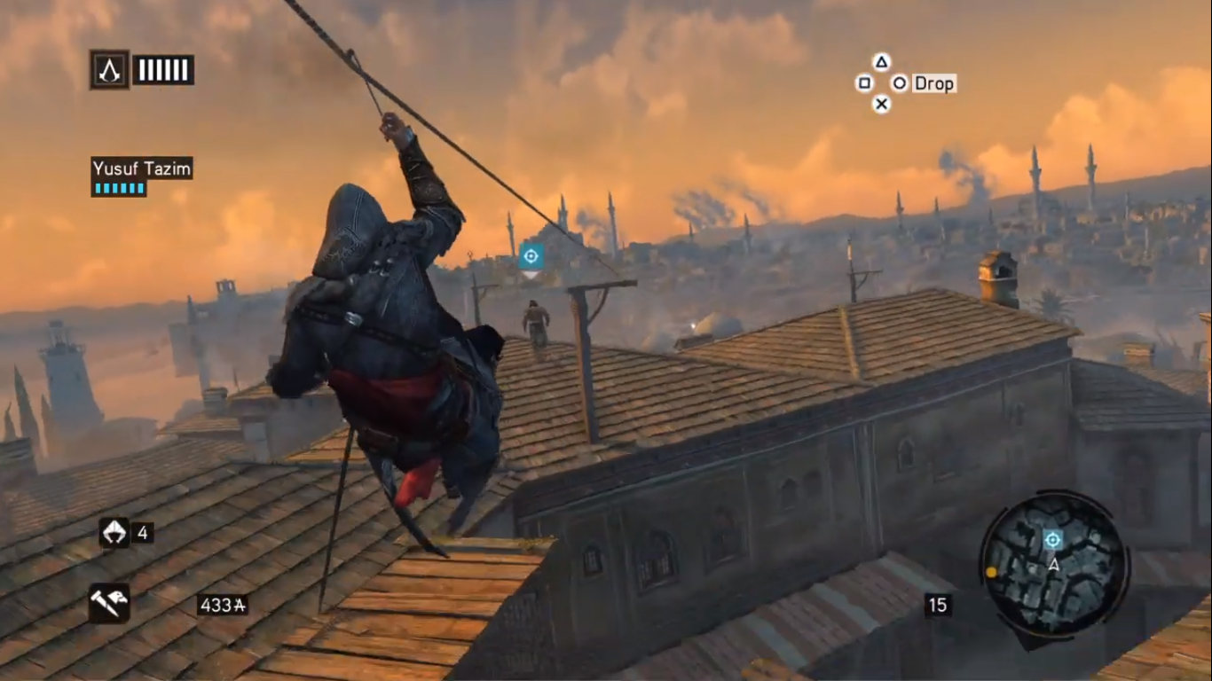

<https://youtu.be/J5vfMgEdTkc?t=56>

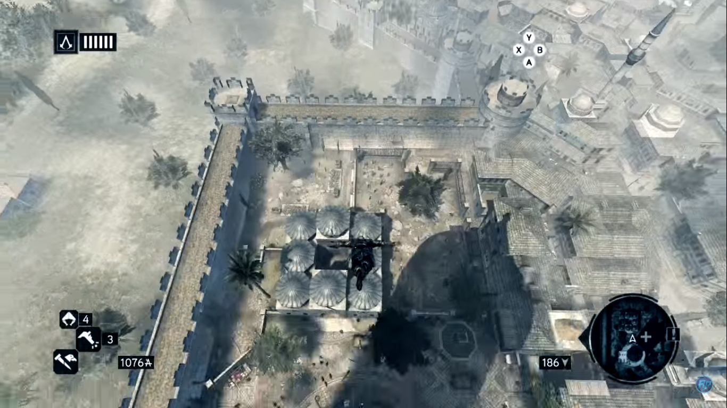

<https://youtu.be/H5mLrCLvDzY?t=28>

**Marvel’s Spiderman (PS4)** Capture and link to video that show a good example for the things we suggest improving.

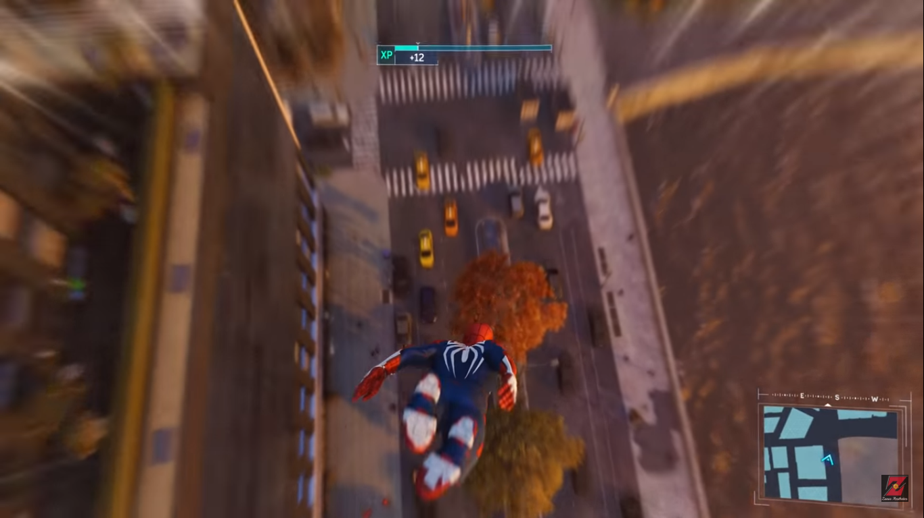

<https://youtu.be/PrD0UkKeBIA?t=105>

One of our suggestions to improve this feedback is to blur the game background keeping the character in the middle of the screen in such a way that the player can see it clearly. This will lead to a moment where all the game environment will be blurred except the player and a little area surrounding him.

With this improvement we also think it would be good to add some white blurred lines pointing to the player in the corners of the screen emphasising it and increasing the speed feeling.

Our last proposal is to increase the volume of sound effects as the wind, the hook slipping on the rope when you are in a zipline, the fabric against the wind sound when you are using the parachute and the animal’s sounds when you are performing leaps of faith.

With these upgrades on the feedback we think the speed feeling can improve a lot.

The next image exemplifies our idea.

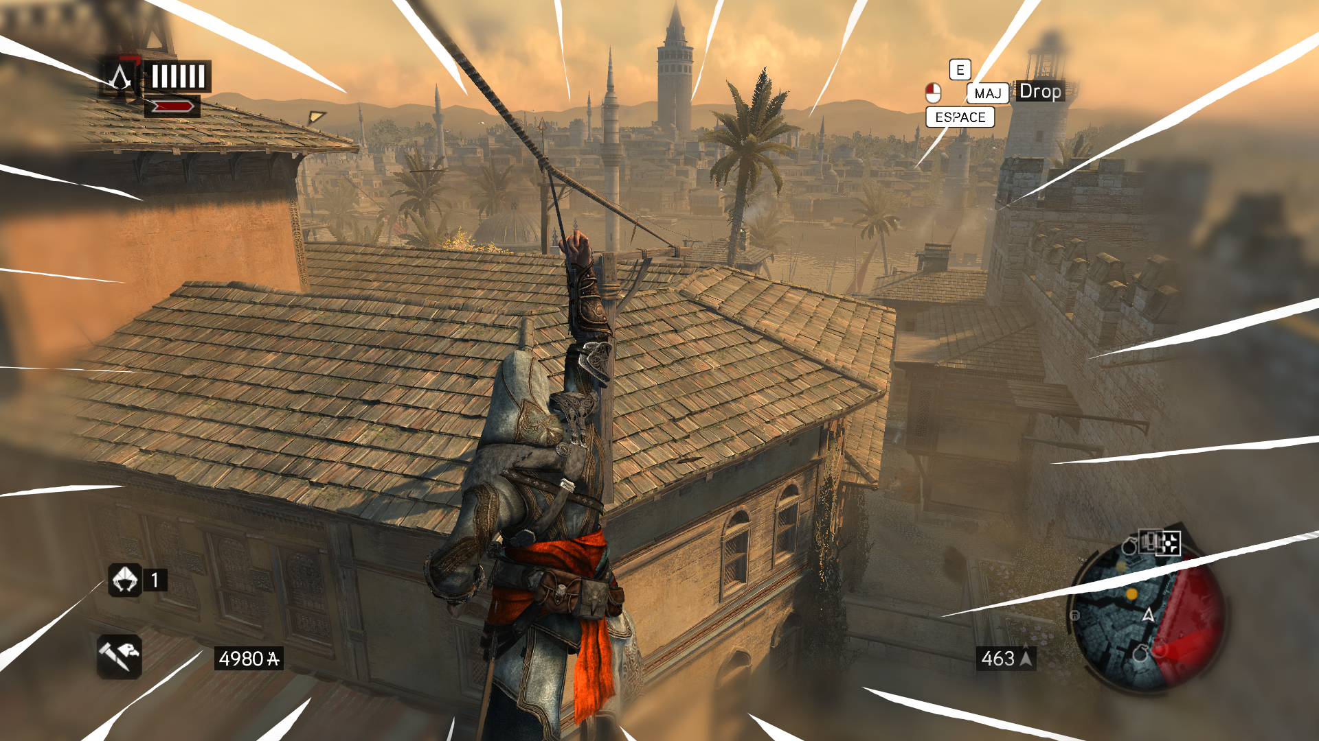

**Improved Readability (“Windex”):** talking about readability here, we can mention some tutorial pop ups that appear on the screen remembering or telling you how the player must proceed. Sometimes, it is only a line of text or two on the left side of the screen, but in other occasions the text comes with an image that covers part of the screen (even in moments of action) and that is not useful at all, staining the view and becoming annoying at some point.

This detail is not only a matter of screen clutter, it becomes in a matter of seeing the game’s inner workings clearly in the same moment it doesn´t allow the player to see the gameplay elements that he needs to see in that moment. “Hiding” the enemies behind the images breaks the gameplay at some point because you are missing essential information about the enemies during the combat (enemy position and movements). It makes difficult to the player to see when the enemies are going to attack, stopping (possibly) the player from blocking the attacks or countering them in the right timing.

If we look for a solution to this problem, we can think on removing completely the images or reducing its size, sometimes only the text is necessary, changing the position of the image could help (moving it to the upper left or right corners, for example). Other solution could be scripting the logic of the tutorial images to make them disappear when you enter in combat mode, for example, and make them appear again when the combat ends. Other way to improve it will be making the images not completely opaque, letting the player see a little bit what is going on behind the image on the scene.

One of the games that exemplifies very good the changes we are proposing is the new God of War (PS4). The tutorial indications comes in form of texts in a position away from the centre of the screen (where the action usually takes place). In addition, the text boxes are not opaque, and the player can see what is behind. The result is a clean game window that allows the player to enjoy the action and the views without any kind of distraction or obstruction to the sight.

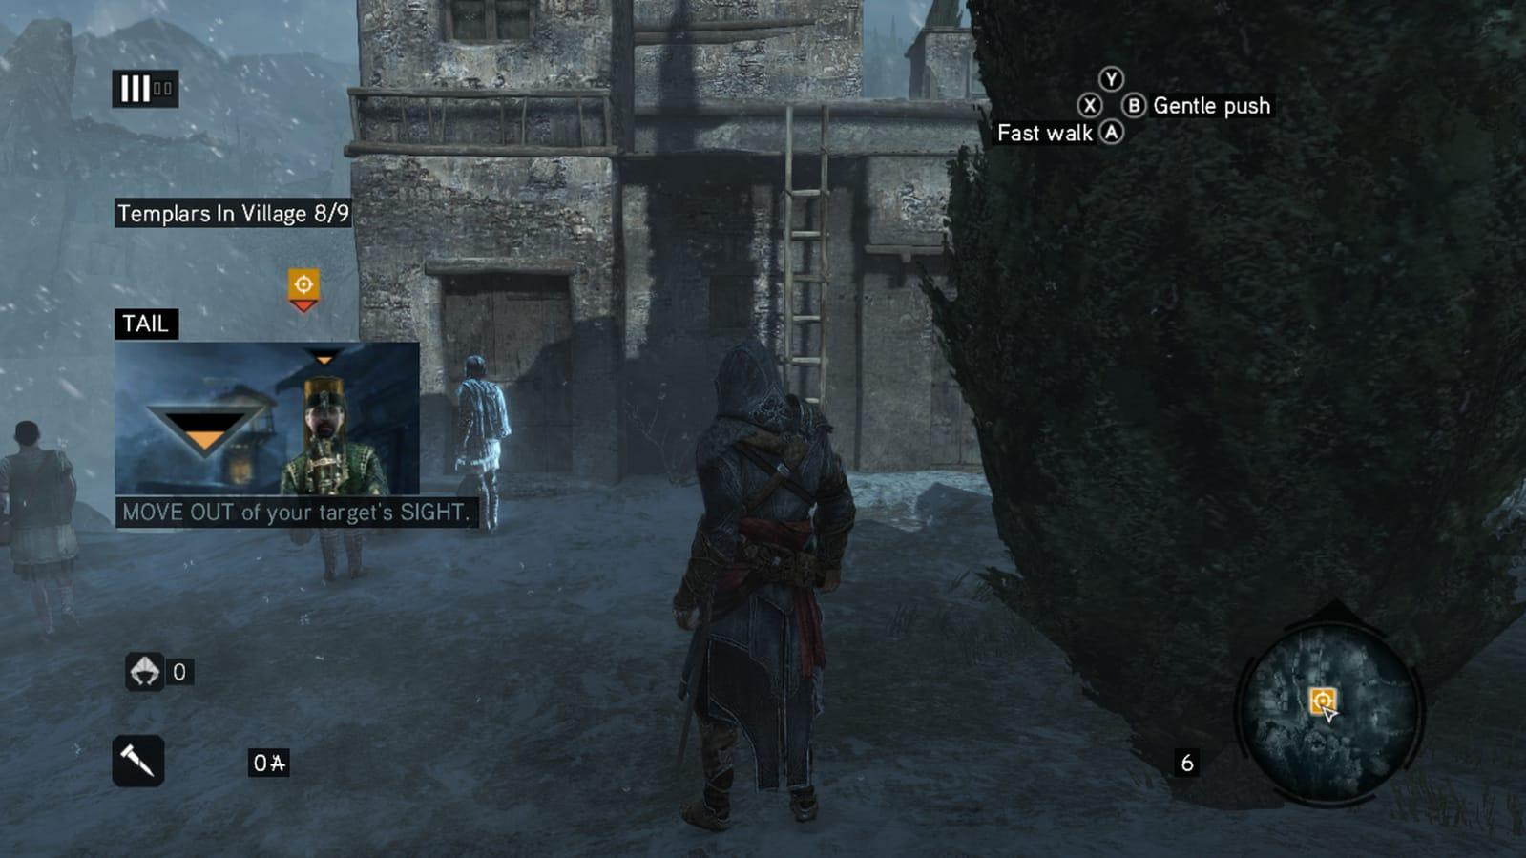

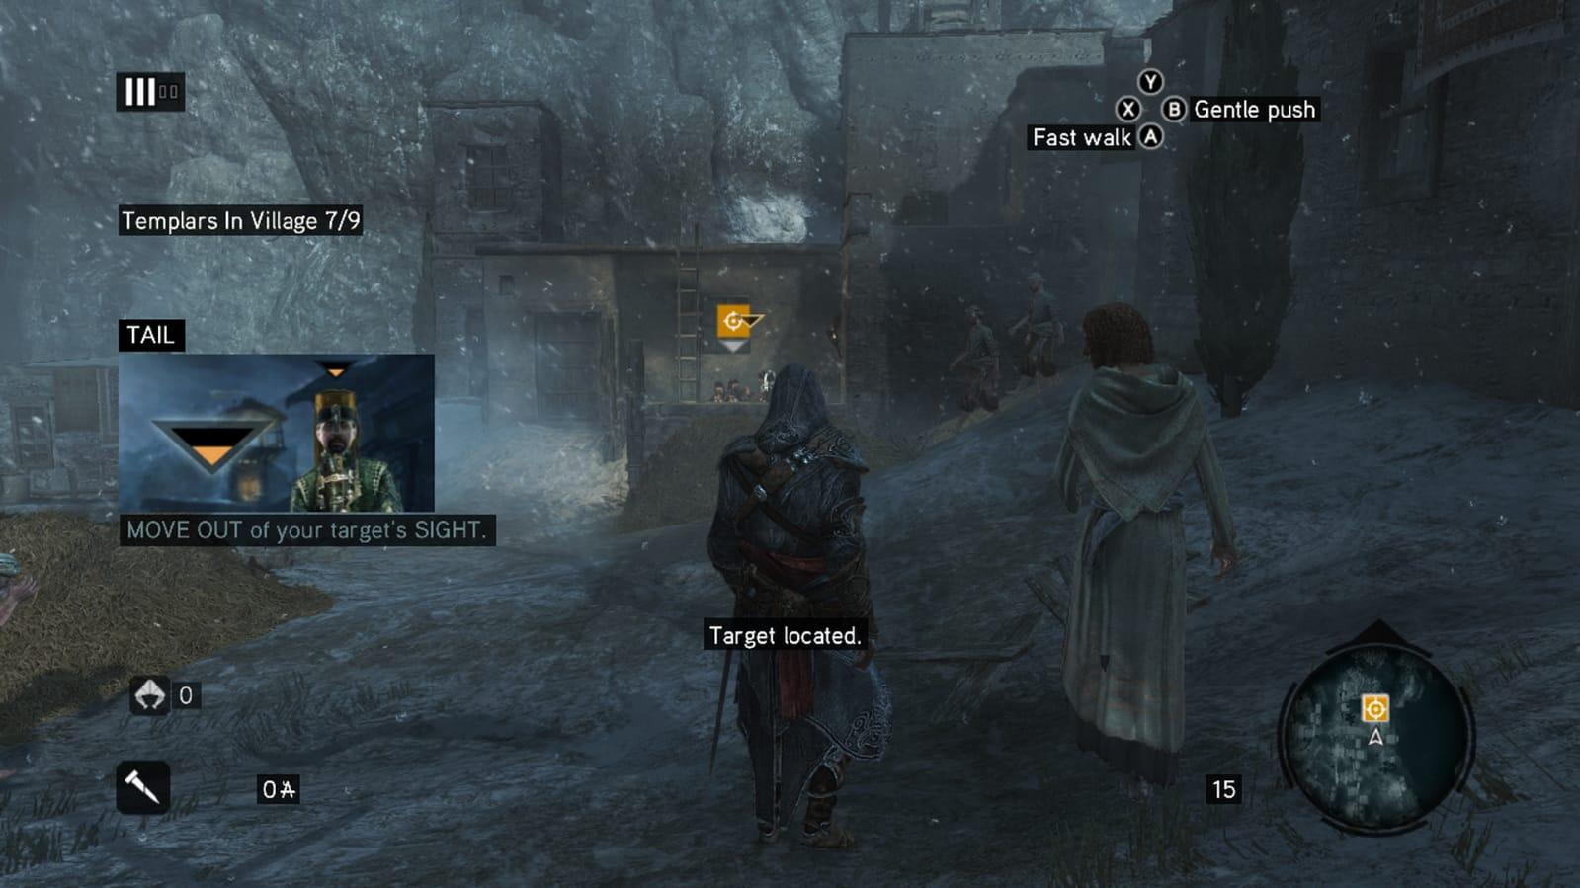

The same message and image appearing in different moments, one of those covering the view of the enemy that precisely is detecting you.

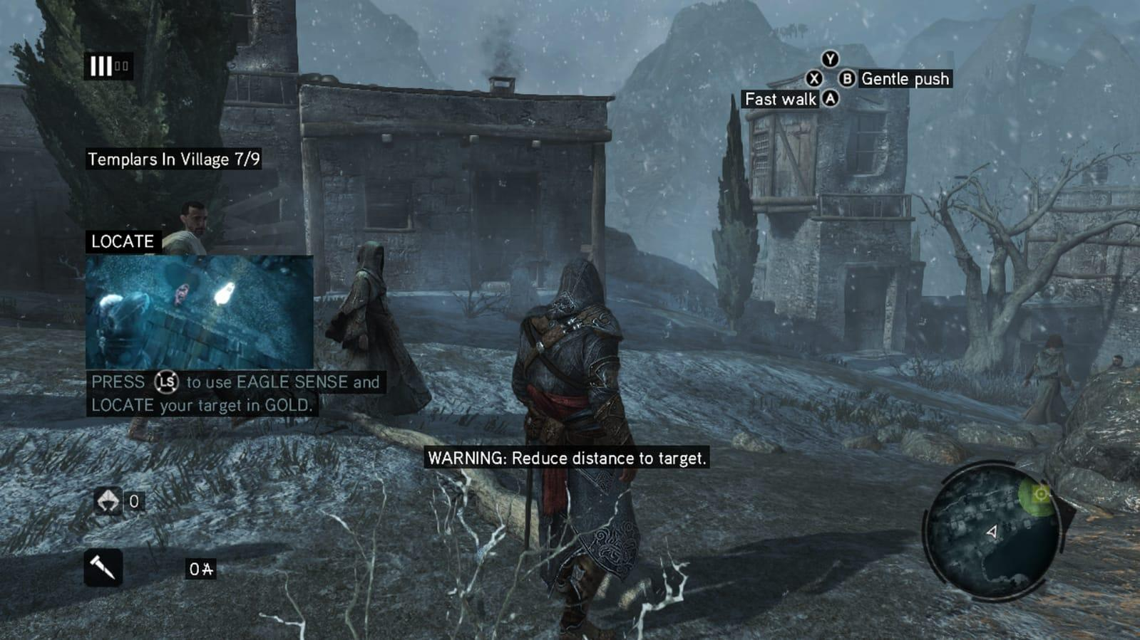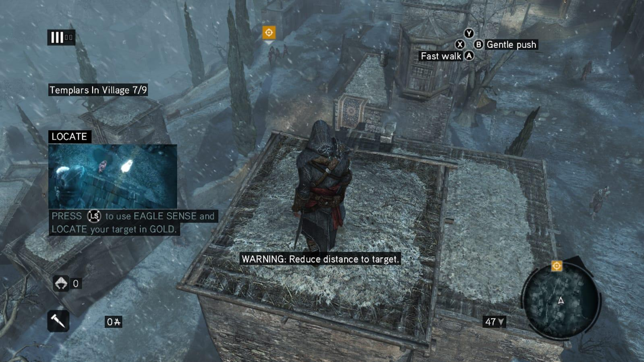

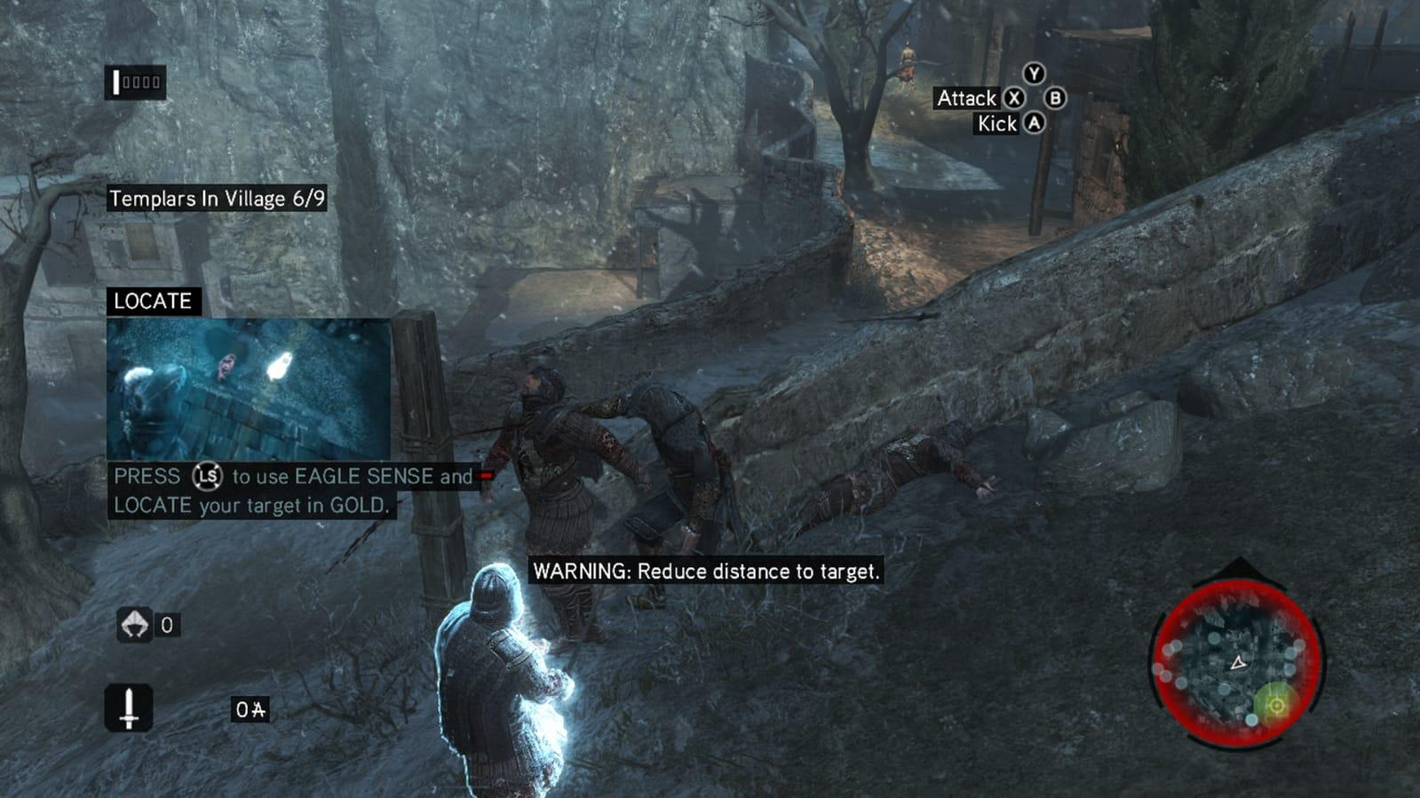

Again, another tutorial advice with his image covering part of the screen. In this case it we can see one example in which it appeared during of a combat.

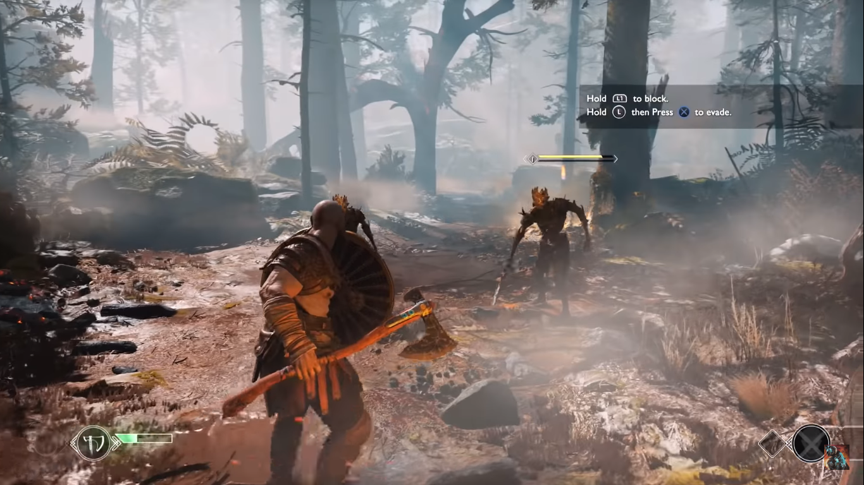

One of the games that exemplify very good the changes we are proposing is the new God of War (PS4).

**Reduce Friction (“Oil”):** referring to this point, we suggest deleting one of the running states of the player.

In the game, the player has 3 different velocities for moving:

* Walking
* Running
* Sprint/free run: With this one particularly, the player must be careful and avoid the citizens to not lose his balance and fall to the ground. It is the one called free run mode, the one that allows the player to interact with the obstacles and walls, to climb, jump across platforms, and do parkour.

Assassin's Creed revelations make the player have two buttons pressed at the same time to enter in parkour mode. It makes you to go into the high profile mode and then press another to enter on that Sprint/Free run mode.

Our proposal is to look for a more comfortable control for the parkour and sprinting states. In this way the player doesn’t have to think in a combination of buttons making the action of running something more natural and immediate.

We have the” Marvel’s Spider-Man” video game as an example that at the end does the same but entering in the “parkour” mode by pressing only a button.

Actually, this is the control model Ubisoft uses on the next games of the saga. We can see this in Assassin's Creed 3 and Assassin's Creed Black flag, by pressing only one button (right trigger on console controllers) the character enters on the sprint /free run mode.

* Walking

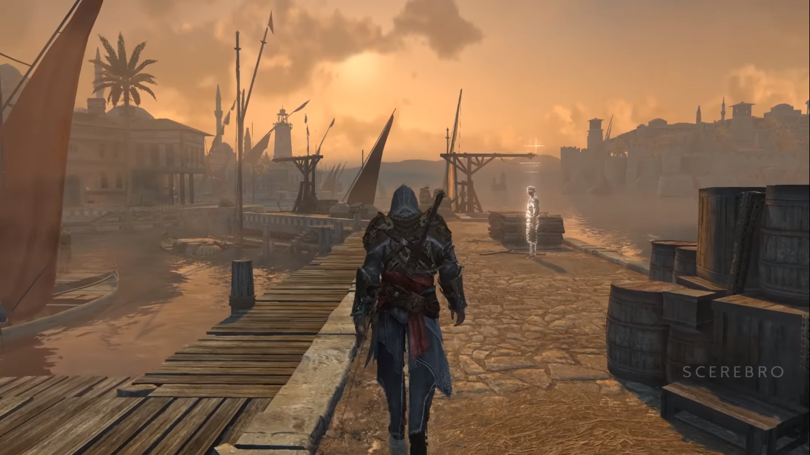

<https://youtu.be/U2dnCUfkUz0?t=65>

* Running

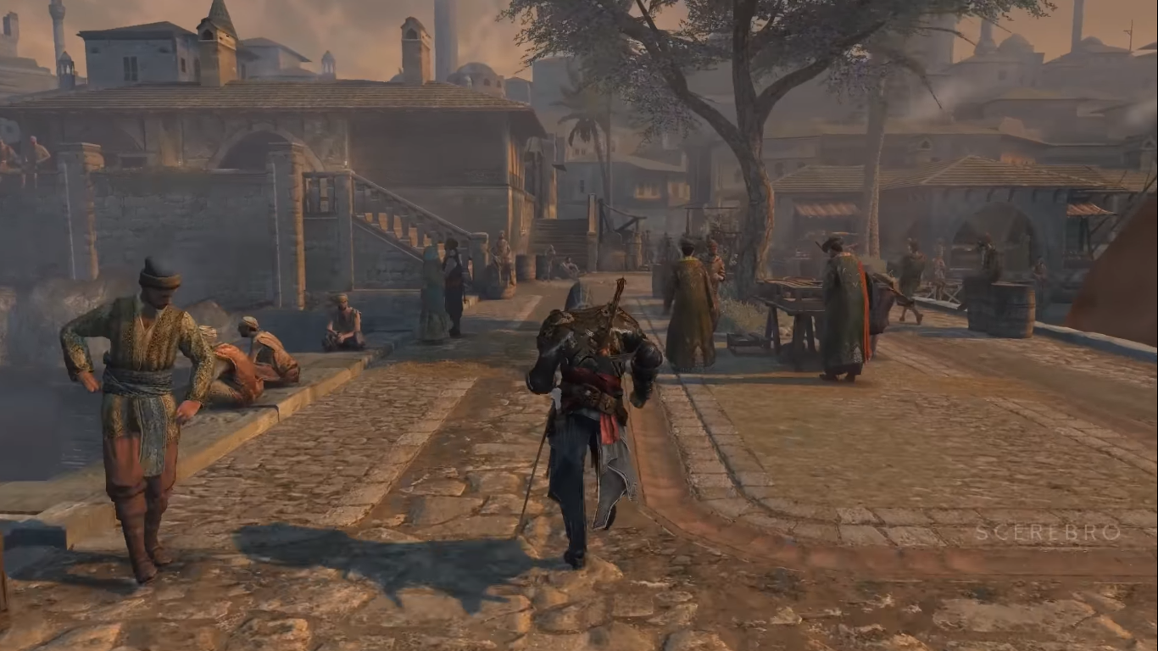

<https://youtu.be/U2dnCUfkUz0?t=148>

* Sprint/Free run

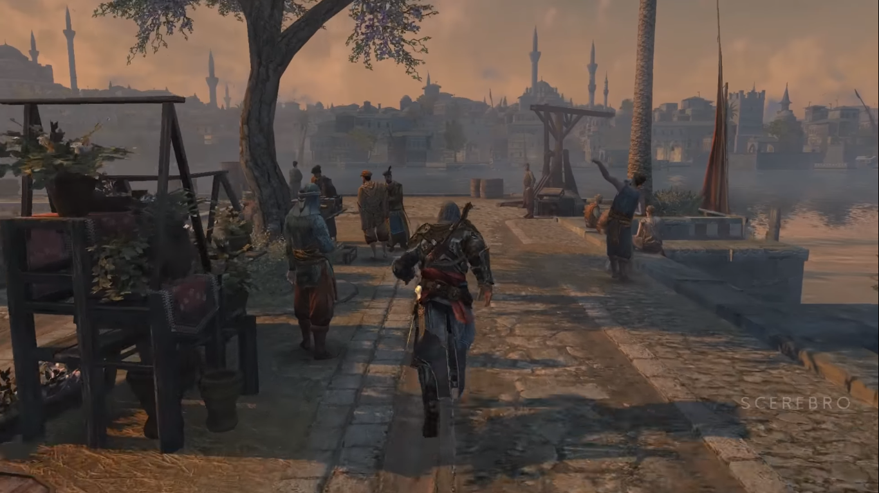

<https://youtu.be/U2dnCUfkUz0?t=229>

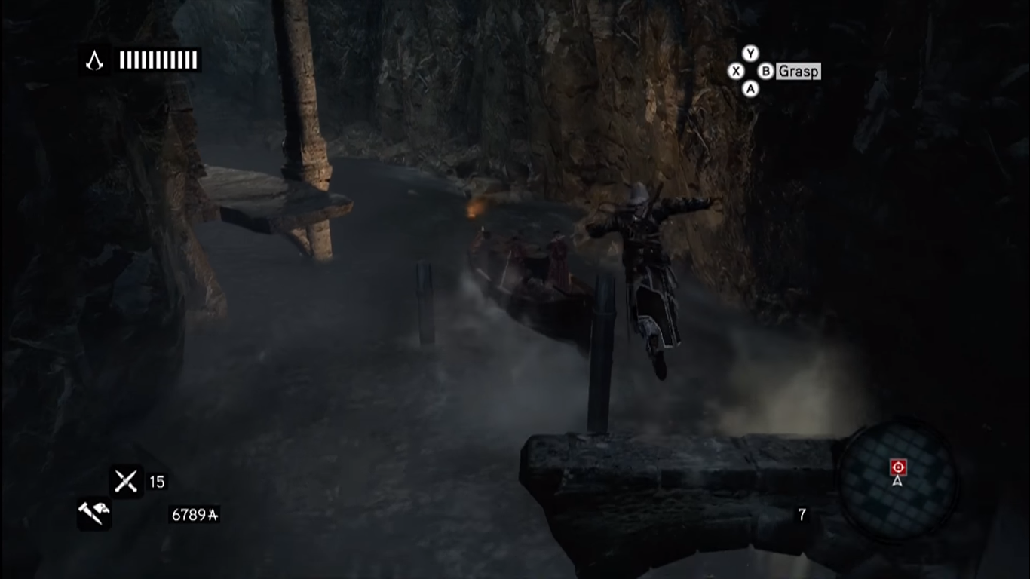

<https://youtu.be/1EXgwgsEAdg?t=20>

We can see on the manual how this movement system is explained. Walking speed is the default speed when you move around with the joystick.

In order to sprint it is necessary to access to the “High Profile” state.

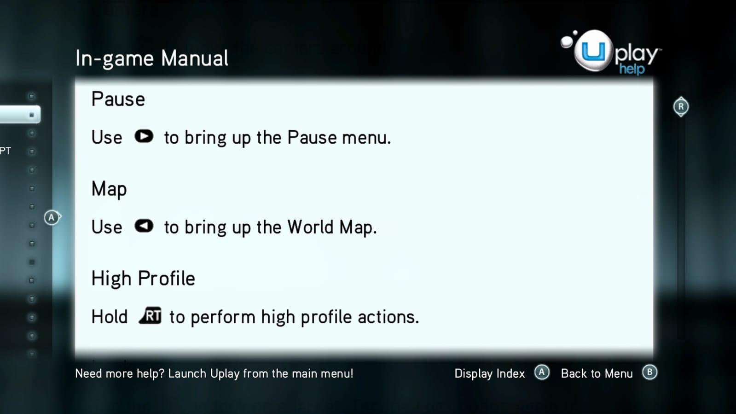

If you are not holding the Rt button you will stay on the “Low Profile” state: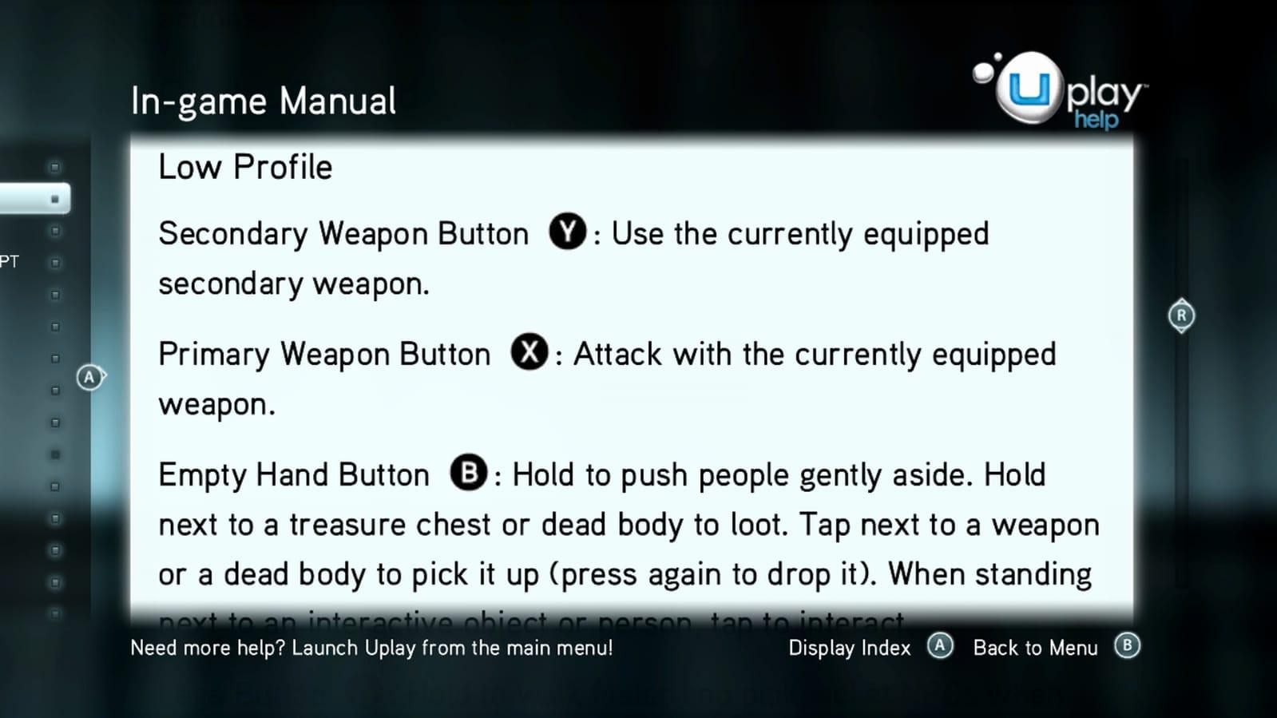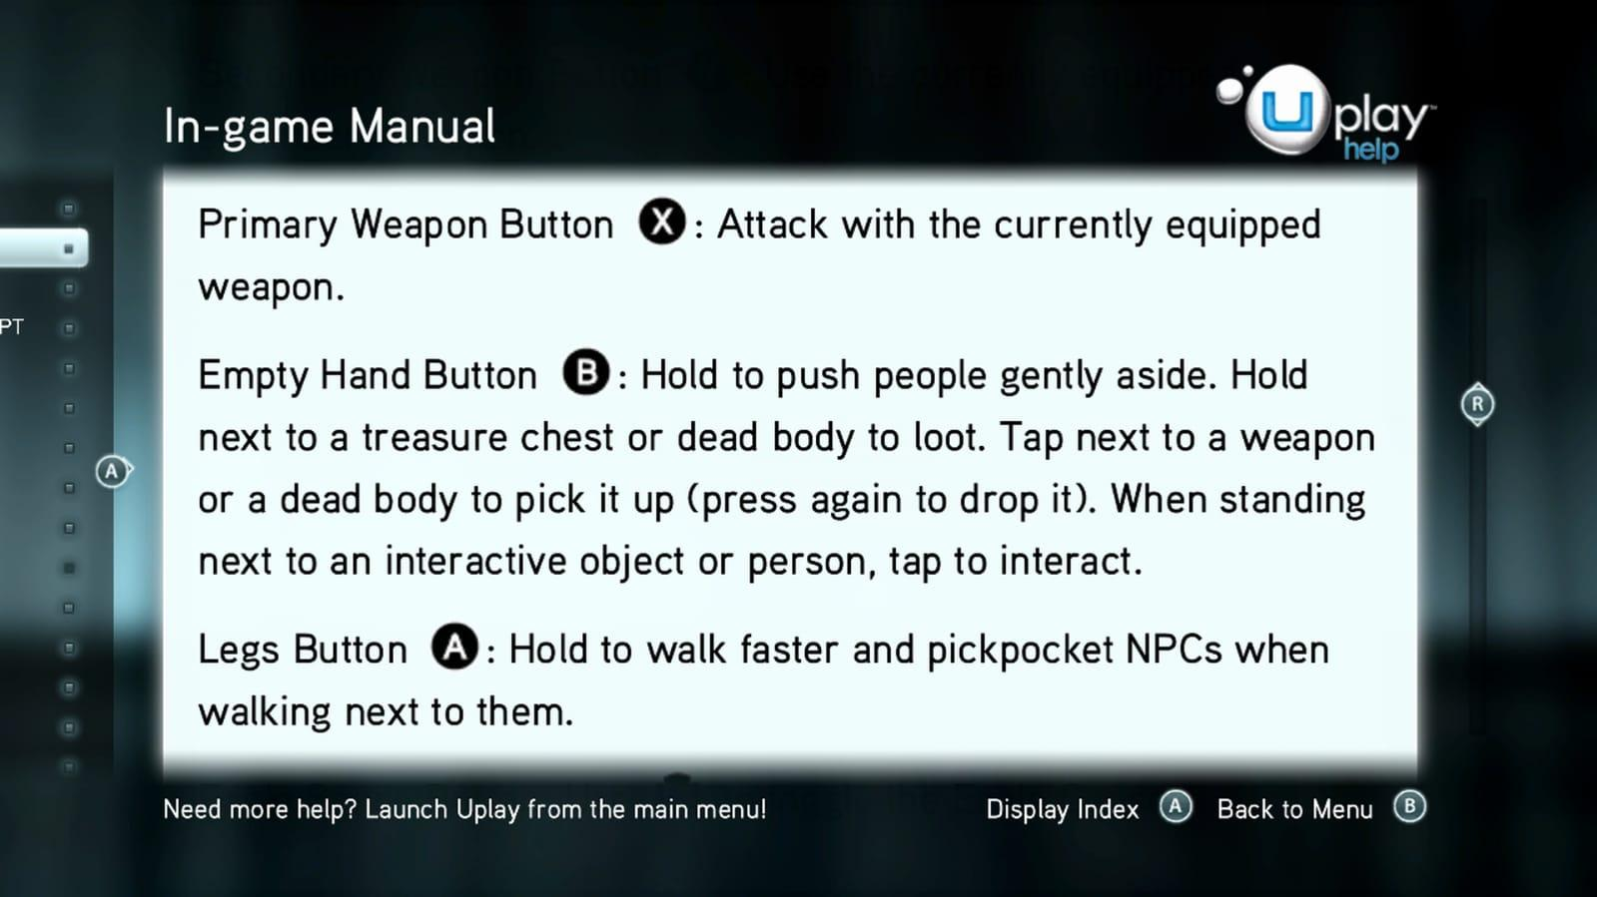

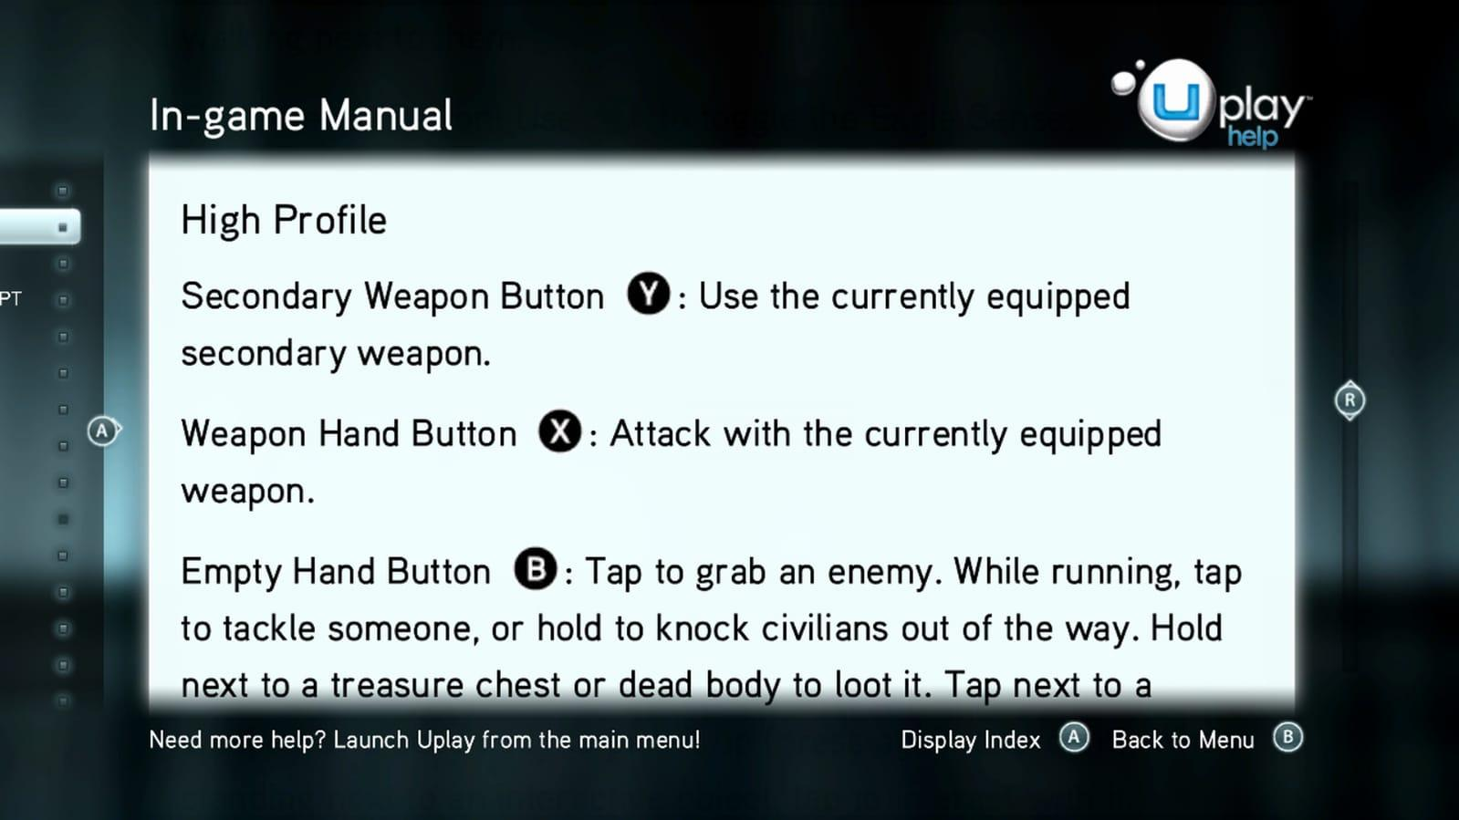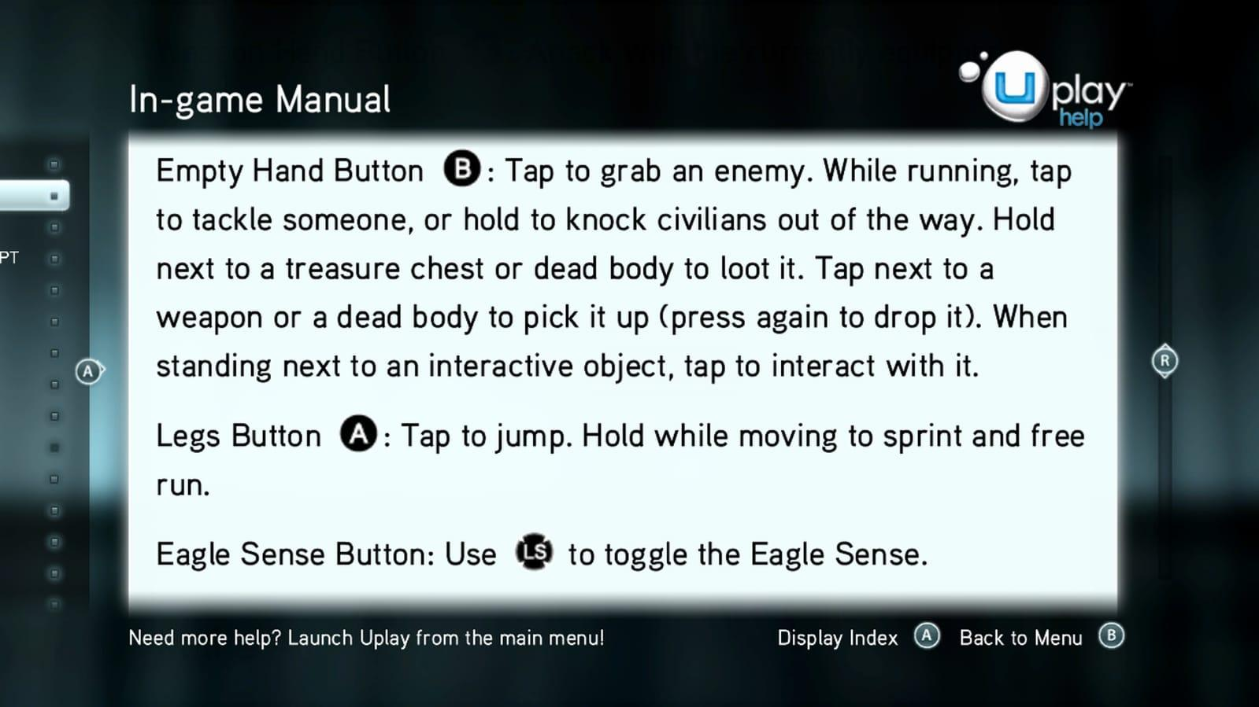

On the other hand, we have the Marvel’s Spider-Man control system (Ps4).

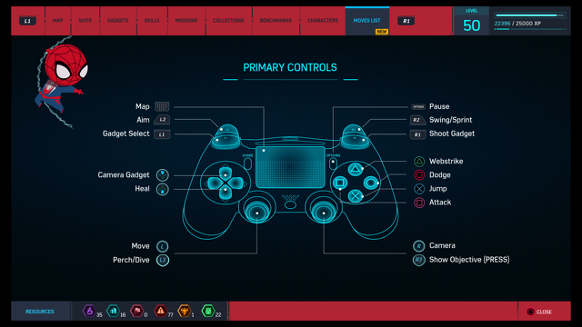

By pressing R2 our character runs and enter on the free run mode in a simpler and more comfortable way. By pressing only one button we can perform the actions described instead of using more, as we must do in Assassins Creed.

As we have mentioned, this is the movement control they use in the previous games of the saga.

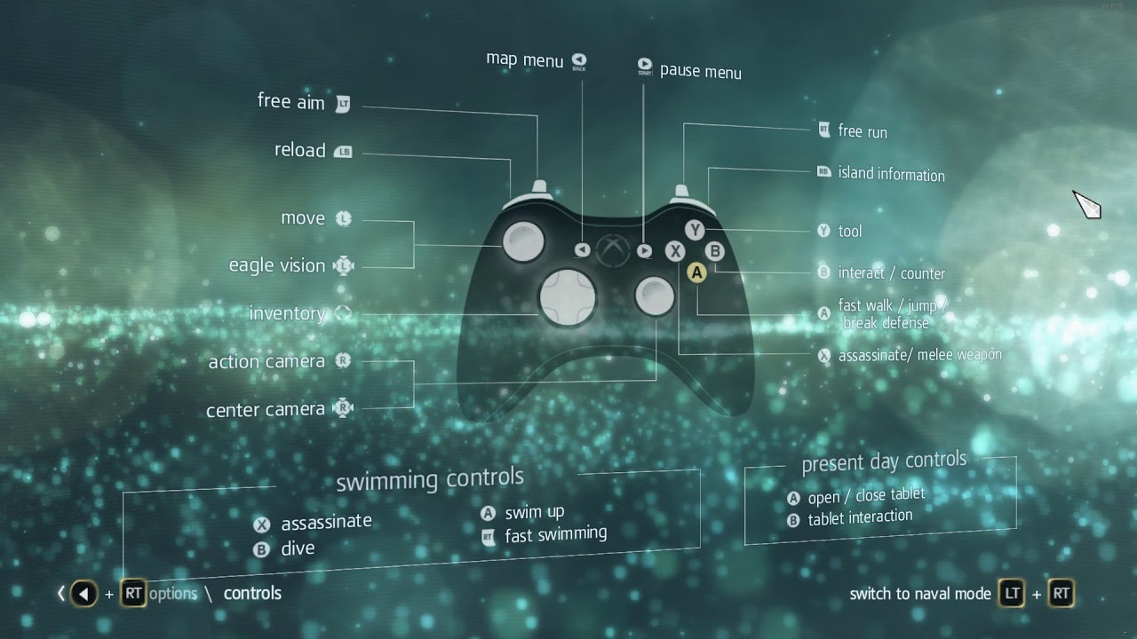

**4. Full design for one of the fixes**

We have chosen to develop our suggestion related with the feedback to improve the speed feeling.

One of our ideas to upgrade this feedback is to blur the corners of the screen to emphasize the character beyond the environment and give that feeling of speed to the player.

This blur effect must be triggered when the player state changes to a zipline, parachuting or leap of faith state and has to be there until the state changes again to another different one.

Related to the blur, we don’t want it so exaggerated, we must be able to see and distinguish clearly the objects around. With a 0.2 or 0.25 of blur we think it will be enough.

Related to the amount of blur, we want that all the screen to be blurred except the main character and a little area of 3.5 or 4 centimetres that surrounds him.

The transition between a state and this new state with the feedback improvements must be smooth in a such way that the area which is going to be blurred do it smoothly using coroutines, applying the same behaviour we can observe when we fade into black a screen little by little.

Another suggestion we think is going to work is implement some white lines around the screen pointing to the character. These lines do not have to be completely white; the colour must fit with the environment so maybe we will need a less flashy white. Artists can experiment with colours like this hexadecimal code: #DEE3DF.

Furthermore, the white lines must be thicker near the corners of the screen and they need to start becoming thin when they approach the player’s position.

We also think an animation that stands out the lines during all the state will be very useful.

In addition, these lines have to appear in a smoothly way like the blur effect when the player enters in this speed state defined for the ziplines, parachuting and leaps of faith.

The amount of space the white lines must take up in the screen is exactly the same as the blurred background, preserving the player and the clean area surrounding him.

Finally, our last proposal is to add some new sounds and increase ambient ones while you are in the speed state.

We suggest to add sounds for the wind, the hook slipping on the zipline, the friction sound between the fabric of the parachute and the wind, the armour and weapons of Ezio moving because he’s in movement and some animal sounds like pigeons and eagles when the player performs a leap of faith.

Keeping in mind these upgrades, we can say that the most expensive one in terms of programming and resources probably is to create this clean area for the player that is exempt from the blur effect and the white lines.

The white lines are also a tricky part because we need that they fit really well with the environment without clashing with it.

However, we think is worth it to spend some time researching how to implement it because it would improve the game in every sense.

**5. Discussion**

We have been discussing about our design and improvements. Some members of other teams think our way to improve the design is correct and that can help to make the game more “juicy”.

They have given us other tips that can improve even more our design as tone down the things on the borders (in addition to the blur) to emphasize even more the action in the middle of the screen.

Also, attenuate the tone of the soundtrack to give importance to the sound of the breeze, the parachute clothing against the wind or the sound of the hook brushing against the zip line. They have suggested that increase a little bit more the camera shake could also help to add juice to our design.

Those would be great additions that we have had in mind when we have written the “full design section”, so we have to say we agree completely.